Prospective New Member  CPM  St. Louis, MO | 
Last Updated: Jun 25, 2025 by Aidan Donaldson

Deal Overview
tl;dr
- Thesis: Acquire a scaled, growing management company in the St. Louis metro area with high retention rates and a sizable maintenance business.
- Key stats (TTM Q1’25):
  - $8.6M of revenue, $4.0M of mgmt. Fees, and $2.3M of PF EBITDA (25% margin)
  - 258 CAs, 35.9K doors, 57 Employees (39 corporate / management, 18 maintenance)
  - 4-yr average retention: 95% CA, 95% door, 98% net management fee
  - CAM Cut: 44% (FY 2024)
  - Revenue Mix: 40% Mgmt fee, 33% maintenance, 9% earnings credits, 6% transfer fees, 12% addendum fees
- Opportunities / Growth:
  - Expand the company’s presence in the company’s secondary markets in Illinois (STL metro) and Columbia, MO; leverage the latter to enter auxiliary markets in MO (e.g., Lake of the Ozarks)
  - Increase addendum billing schedule (currently only 12% of revenue from addendums)
  - Further develop sales and marketing function to accelerate growth
  - Expand accounting only and other lower touch services to unlock larger core market; Company currently aims to only serve associations with monthly fees greater than $1,000, and passes
  - Take advantage of pricing opportunity with transfer fees (at or below market average currently)
  - Expand maintenance business, which currently focuses on exterior handywork, to include services such as plumbing, janitorial work, and fire safety
  - Inorganic growth; CPM has made two historical acquisitions, and has an appetite for further opportunities which could unlock new adjacent markets (e.g., Kansas City)
- Considerations / Risks:
  - Both owners would like to walk away from the business over the next couple of years, meaning we would need to hire and train a new President, particularly to lead business development
  - CPM has 30% of its CAs in Illinois and another 21% in Columbia. Columbia has struggled to grow, in large part due to a local competitor who has historically undercut pricing
- Software and Banking:
  - Client Accounting: Vantaca & Spectrum
  - Corporate Accounting: Vantaca
  - Transfer & Resales: CondoCerts
  - Payroll: Innova
  - Client Banking: First Citizens
- Ownership:
  - Bob Klages (CEO): 47.5%
  - Jane Oliver (President - runs corporate accounting and oversees STL managers): 47.5%
  - Bobbie Bergmire (CFO - runs client accounting): 5.0%
- Transition Plan:
  - Roles
    - Bob and Jane will stay for the business for at least 18 months as part of the transaction (1x turn of EBITDA is tied to their staying on). Jane may stay involved longer in a part-time advisory capacity.
    - We will need to hire a new MCP to eventually replace Bob, with a focus on sales and marketing
    - Jane’s duties can likely be taken over by Bobbie (current CFO - leads client accounting functions) and TCC’s centralized accounting resources
- Other relevant info:
  - CPM Data Room
  - CPM Info Sheet
  - CPM Diligence Workbook
  - CPM Info Call
- Deal Terms:
  - $26.0M EV @ Closing (~11.5x PF EBITDA, ~11x TTM EBITDA)
    - $21.8M Cash at Closing
    - $4.3M Seller Note (18 months, 6.5% interest, quarterly interest and principal payments)
    - $2.4M Retention Earnout tied to Bob and Jane remaining with the business for 18 months
    - 2026 earnout paying 12x any incremental EBITDA above $3.0M

Transaction overview
CPM is based in St. Louis, Missouri, with offices in Illinois (serving the broader STL metro area) and Columbia, MO. The company services ~260 CAs and 36K units, with ~60 employees. The Company is highly respected in its markets, and has enjoyed strong employee and customer retention. Additionally, CPM has historically completed two portfolio acquisitions with high retention post-closing. The organization has a sizable maintenance business representing approximately a quarter of total revenue. The maintenance business focuses on small exterior jobs (e.g., small repairs to siding) rather than homeowner work, and has broad penetration across the portfolio (management estimates 90% of their condominium clients use in-house maintenance for small jobs).
CPM is owned primarily by Bob Klages and Jane Oliver, who each control 47.5% of the company. Their CFO, Bobbie Bergmire, owns the remaining 5%, and manages client accounting. Bob and Jane would like to retire, but have agreed to stay with the business for at least 18 months to oversee a transition and have a retention bonus equal to ~1.0x EBITDA tied to doing so.

Transaction Details

Underwriting EBITDA and Valuation (Member Company)
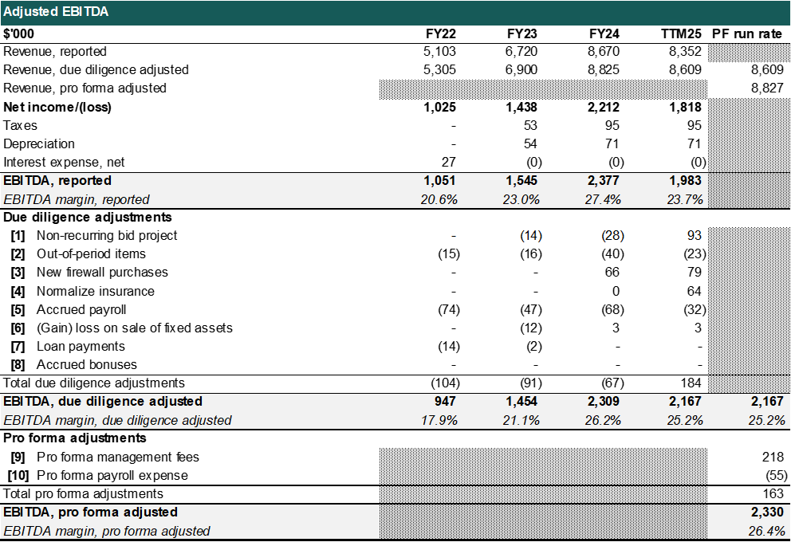
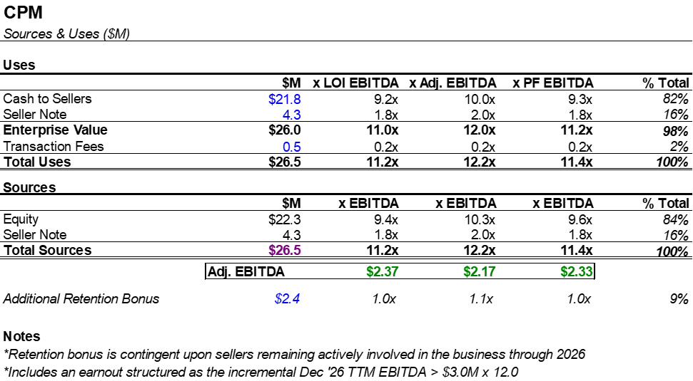

Adjusted EBITDA:
- Adj. 1 is a correction to the timing of revenue and expense recognition on a large capital project completed primarily in Q1’24
- Adj. 2 normalizes out of period items, the largest drivers being reimbursements for employee insurance and a gain generated from writing off old payables
- Adj. 3 reflects one time cybersecurity upgrades completed in 2024
- Adj. 4 normalizes prepaid insurance from cash to accrual
- The PF adjustments annualize the impact of new management fees while offsetting for run rate payroll based on 2025 compensation

LOI EBITDA was $2.37M; the PF Adj. EBITDA reflects a decline of ~$50k . The decrease from bid EBITDA was driven by an especially large capital project rolling out of the TTM period (the business has otherwise seen strong growth over the past year).

Valuation: 11.2 PF EBITDA at closing ($26.0M EV @ Close) with 15% in a seller note. The bid valuation was 11.0x.

Seller Note: 18 month term with a 6.5% cash interest rate, interest and principal paid quarterly.

Retention Bonus: ~1.0x EBITDA is tied to the primary sellers, Bob and Jane, staying involved for at least 18 months

Earnout: 2026 earnout paying 12x any incremental 2026 EBITDA above $3.0M

Employment Agreement: We will sign an 18 month employment agreement with Bob and Jane with the opportunity of continuing to work part time after if she’d like. We’d also sign a two year employment agreement with Bobbie.

Org Chart

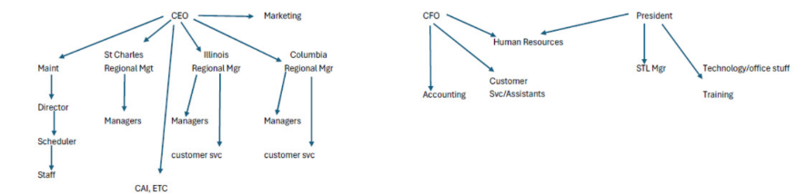
CPM has a strong leadership organization beneath the three sellers. Bob oversees the leader of the maintenance organization and regional market heads for St. Charles, Illinois, and Columbia. The market heads support his marketing and business development efforts in their territories, with the St. Charles lead supporting marketing across the entire organization. Bobbie directly oversees the client accounting team as well as the customer service / assistant manager function. Jane owns corporate bookkeeping, oversees the St. Louis managers, and IT / technology.

Reported Revenue Breakdown
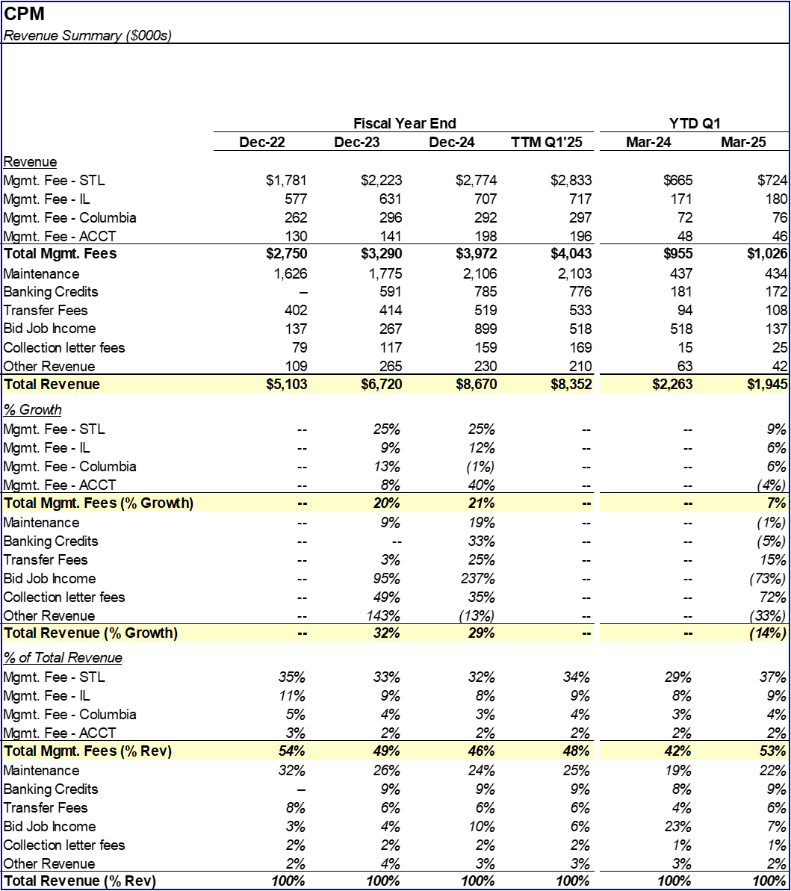

Commentary:
Bid job income tripled from ‘23 to ‘24, driven by a single large roof replacement project, and has reverted towards historical performance over the TTM period. The increase in earnings credit income was due to the timing of CPM’s earnings credit agreement with First Citizens beginning in May 2023. The agreement is a floating rate based on Fed Funds, and is similar with other MC agreements.

STL has grown faster than Columbia due to pricing competition in that market; CPM positions itself as a more premium provider, which has allowed for some undercutting.
Maintenance revenue growth has driven largely from the addition of several dedicated employees at CPM’s largest customer (and the largest Condo association in MO). This customer has also driven an uptick in bid job income due to a project to replace approximately 1,700 decks across the association. As of Q1’25, approximately 300 have been completed, and management estimates the project to continue for another ~3 years.

Summary Income Statement
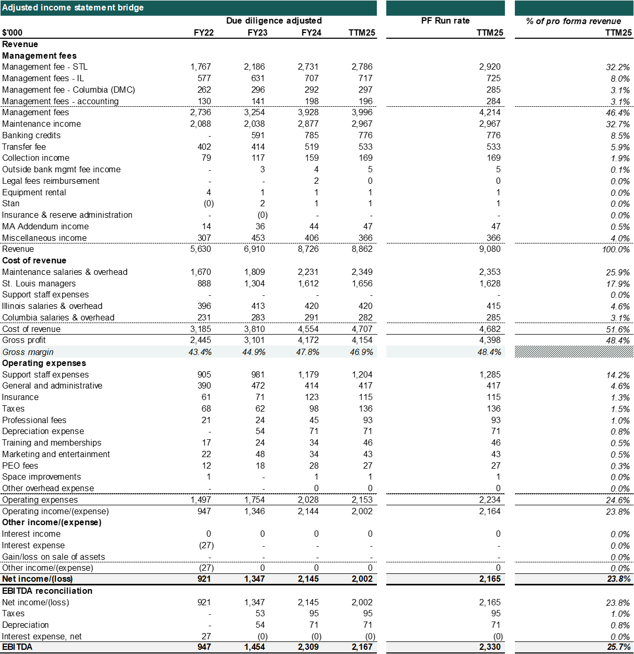

Commentary
CPM is a high margin organization (26% PF margins) with 30% overall revenue generated from the company’s maintenance income. Profitability has been driven by excellent employee and customer retention, which has allowed for strong utilization and efficiency and lean support operations, particularly in accounting.

Underwriting Model
In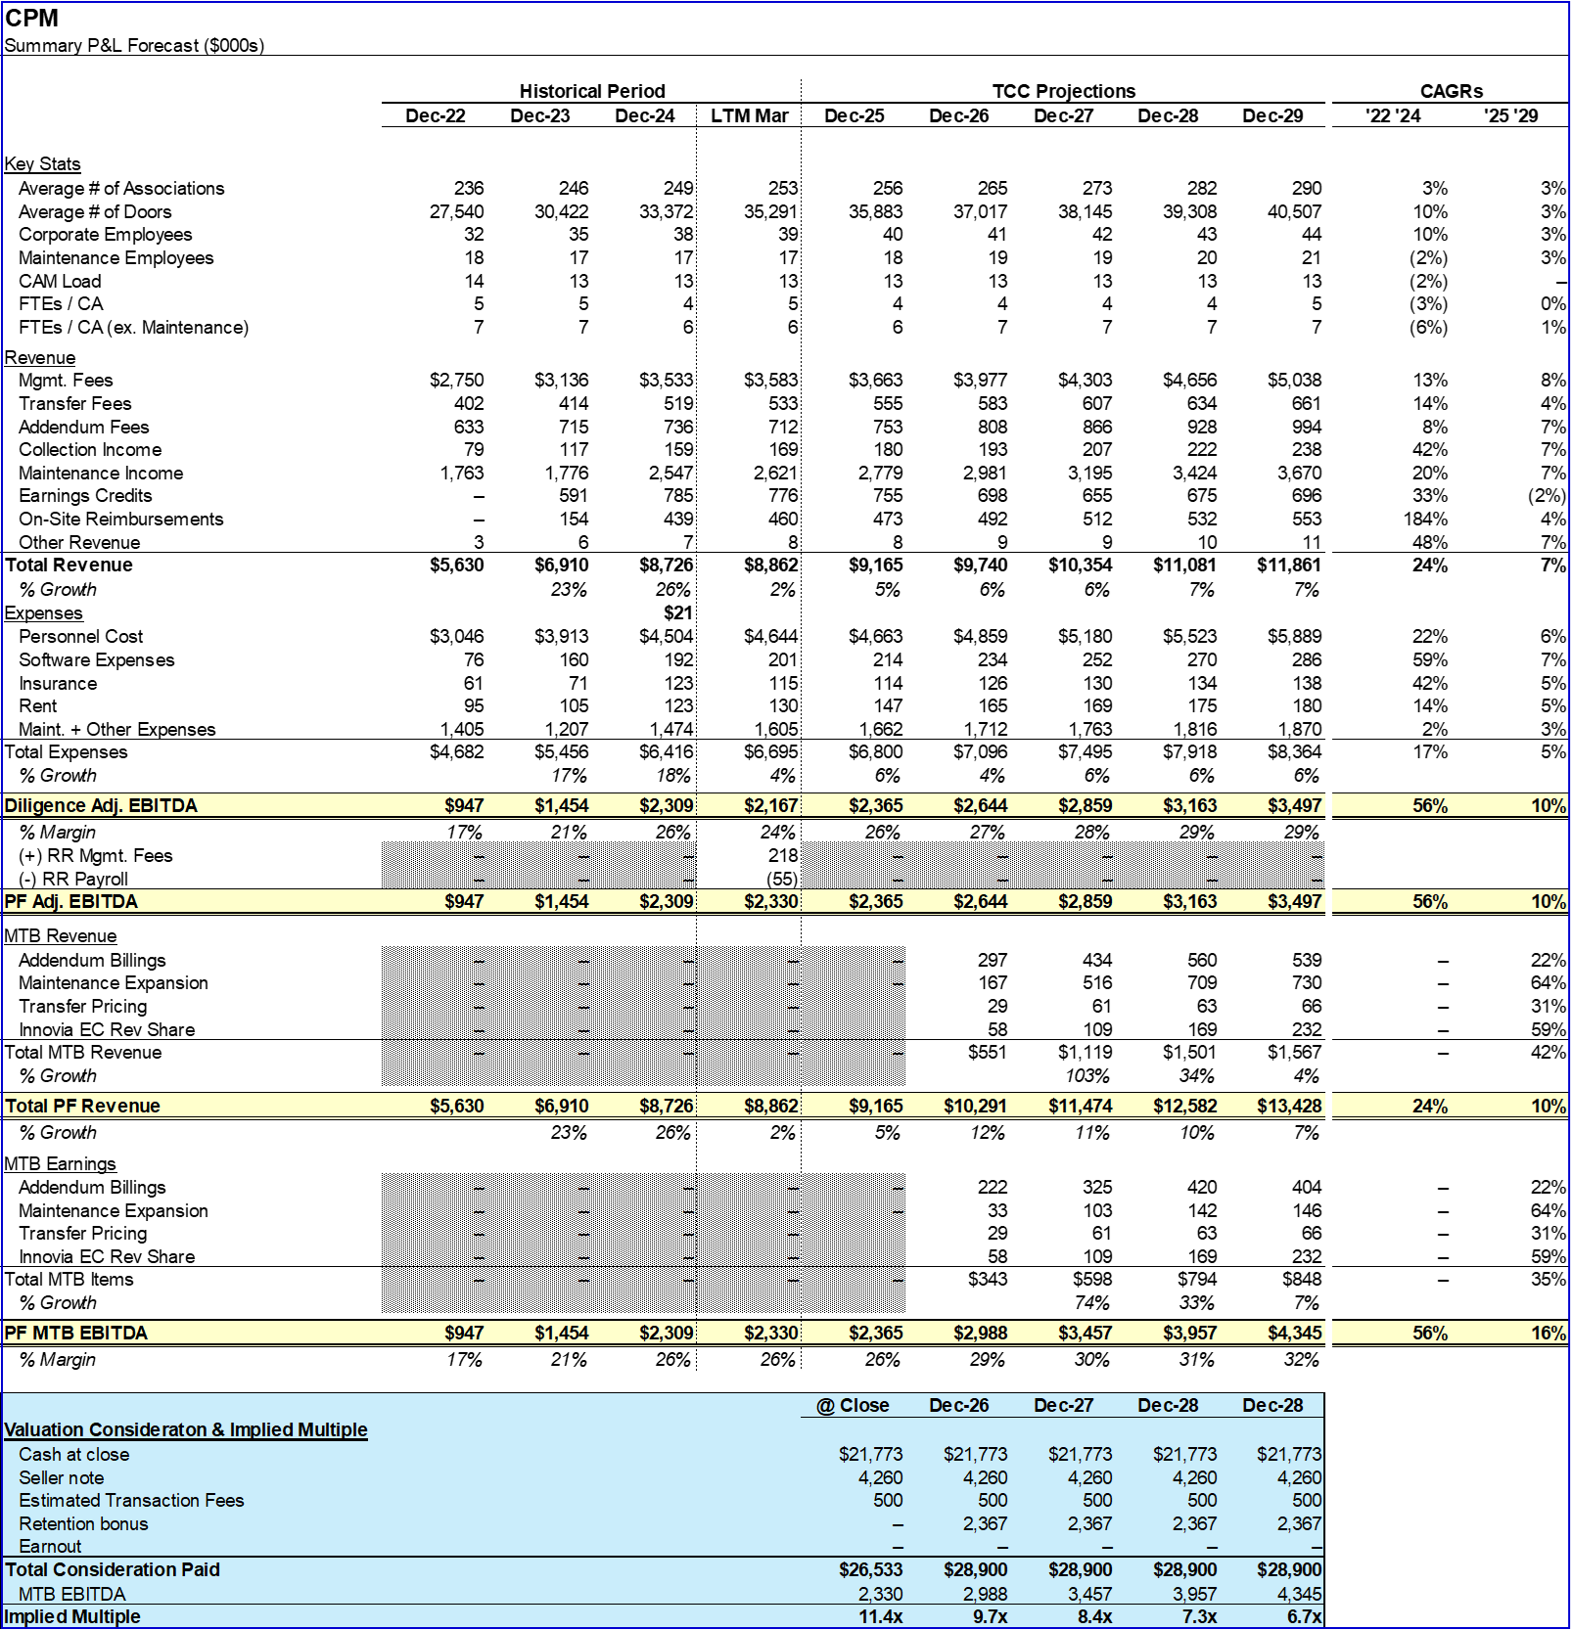

Customer Analysis
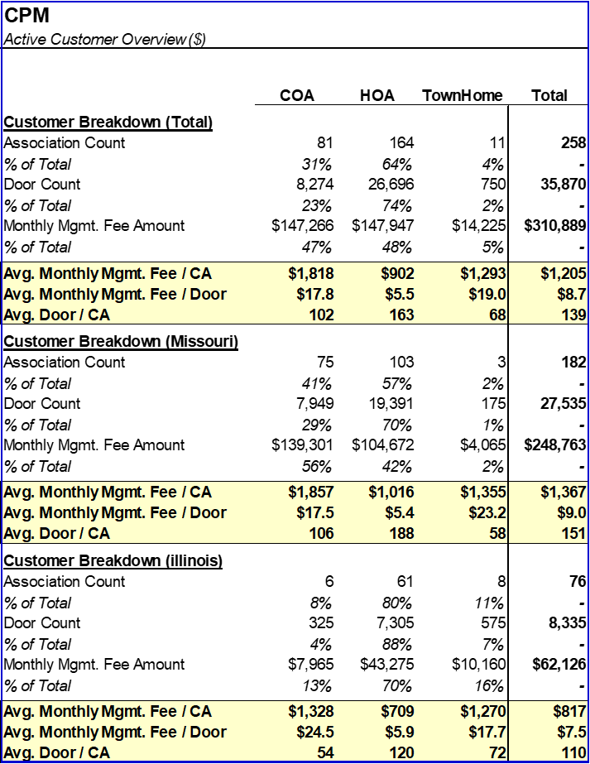

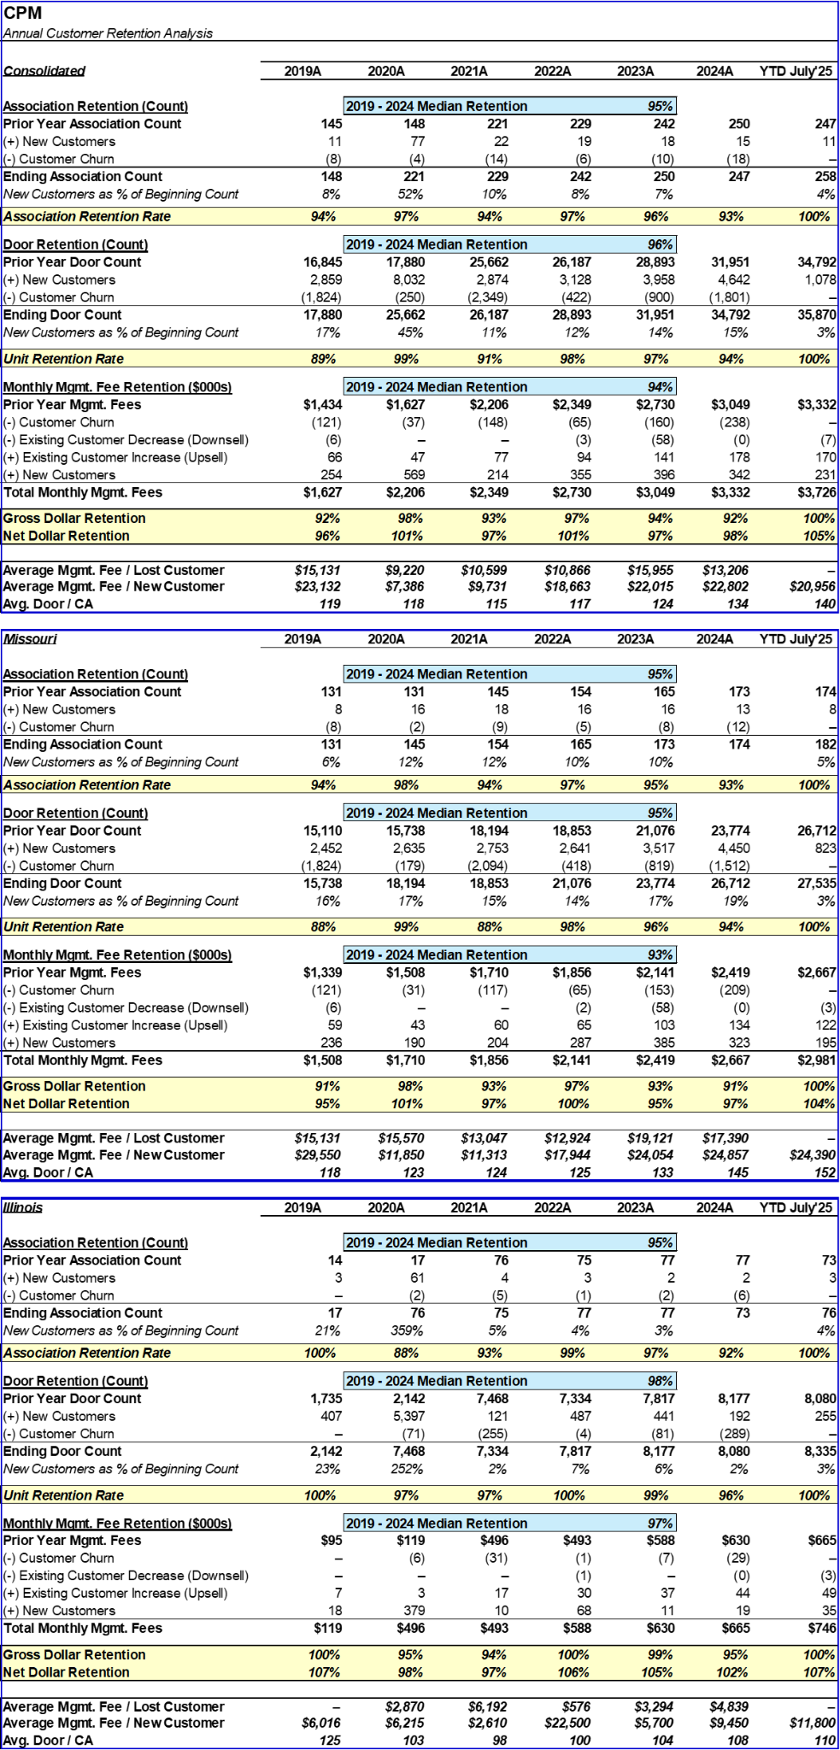

Commentary:

CPM serves a customer base that is approximately ⅔ HOA, ⅓ Condos, though the management fee split it closer to 50/50. The Illinois and Columbia portfolios are more suburban and thus skew towards HOA. While they have accounts that have sub-$1k monthly management fees, particularly in the suburban markets, these are not the primary focus area for the business. CPM prefers condo clients as they are easier to cross sell maintenance work into, though they do not underwrite any cross sell when pricing those accounts.

CPM’s customer retention has been consistently strong for the past several years. Customer churn has been focused on associations that either (a) were looking for a lower cost option or (b) switched to self management (often hiring their own manager directly). CPM currently only serves a handful of accounts with an onsite manager; this is a potential growth opportunity if they can more broadly develop an offering for that market segment.The company has grown steadily over the past few years, and has successfully brought on larger clients as is reflected in the average wins metric.

Employee Breakdown
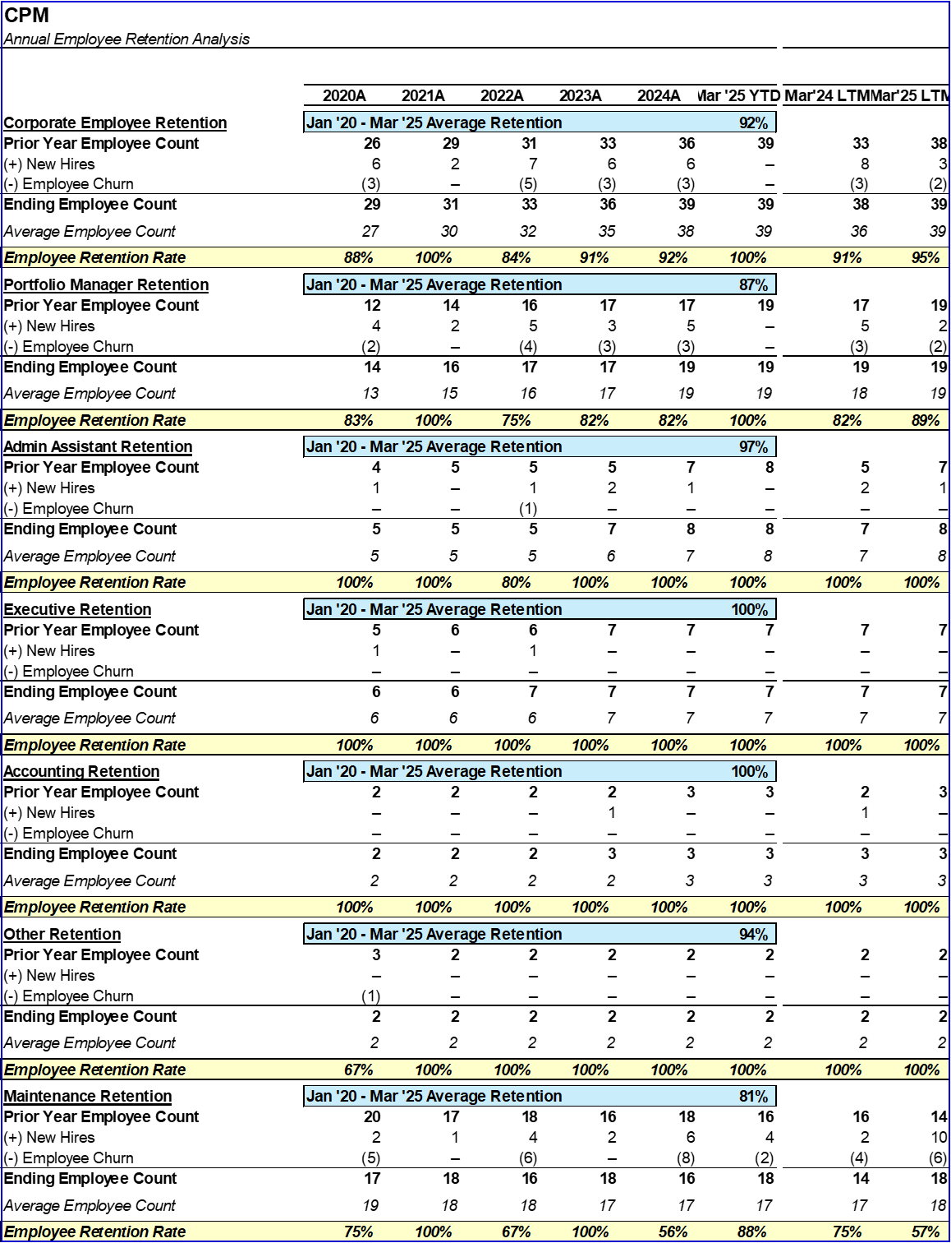

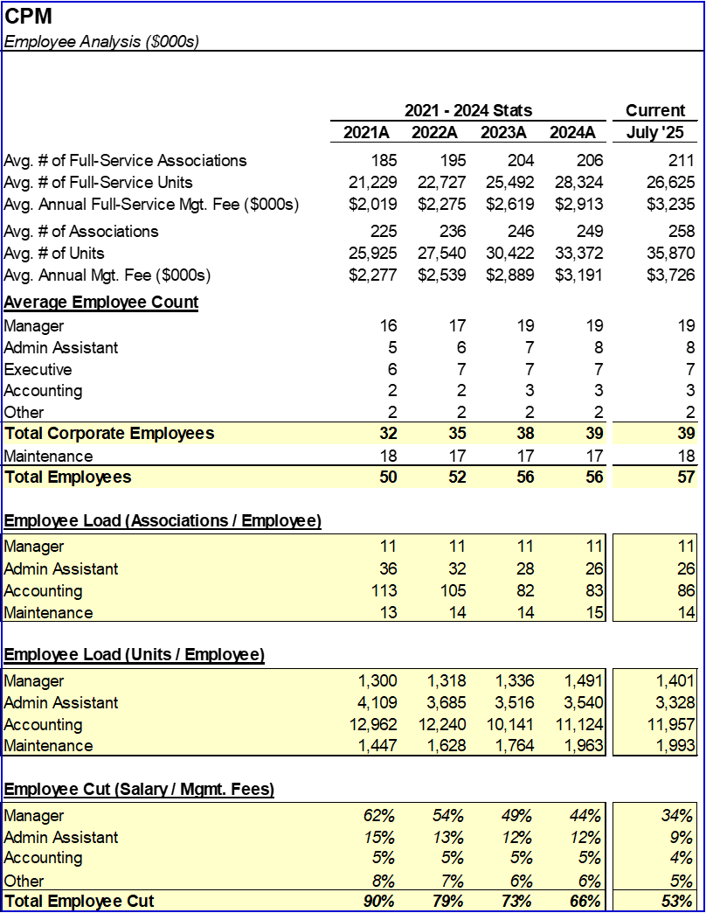

Commentary:
CPM operates with a CAM cut and mgmt. fee cut in-line with our industry expectations. Sellers noted that all but one manager currently has capacity to take additional accounts, and no additional managers are needed for the foreseeable future. The accounting function is significantly smaller than many companies have as managers are expected to handle items such as payables processing and budgeting.

One of CPM’s largest strengths is its excellent track record of corporate employee retention. The Company has historically experienced minimal turnover, particularly in the critical manager function. Sellers ascribe this success to (1) paying at or slightly above market rates for talent and (2) ensuring a deep enough bench to avoid overworking the team.

Business History
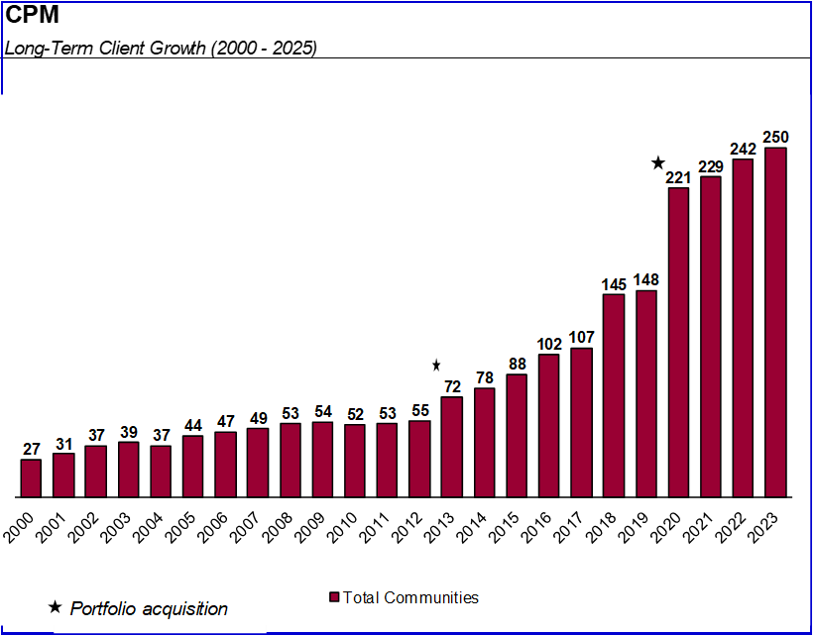
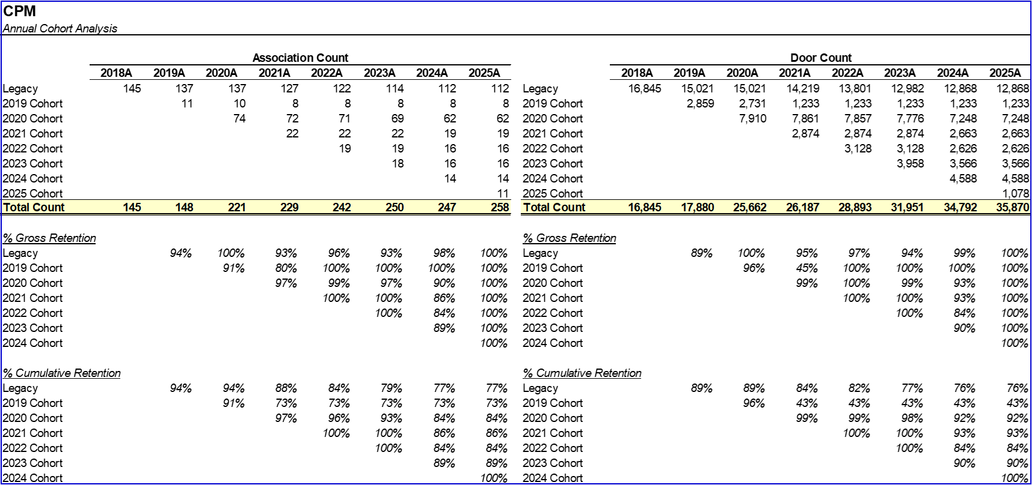
Commentary:
CPM has been active for ~30 years, and has seen a steady yet consistent growth trajectory. The business stagnated slightly through the GFC, but began growing significantly over the following years after Bob joined and revamped their business development efforts. Additionally, CPM has completed a few small acquisitions, which have helped to scale the business. Impressively, the Company has retained a large portion of these accounts.

St. Louis Market
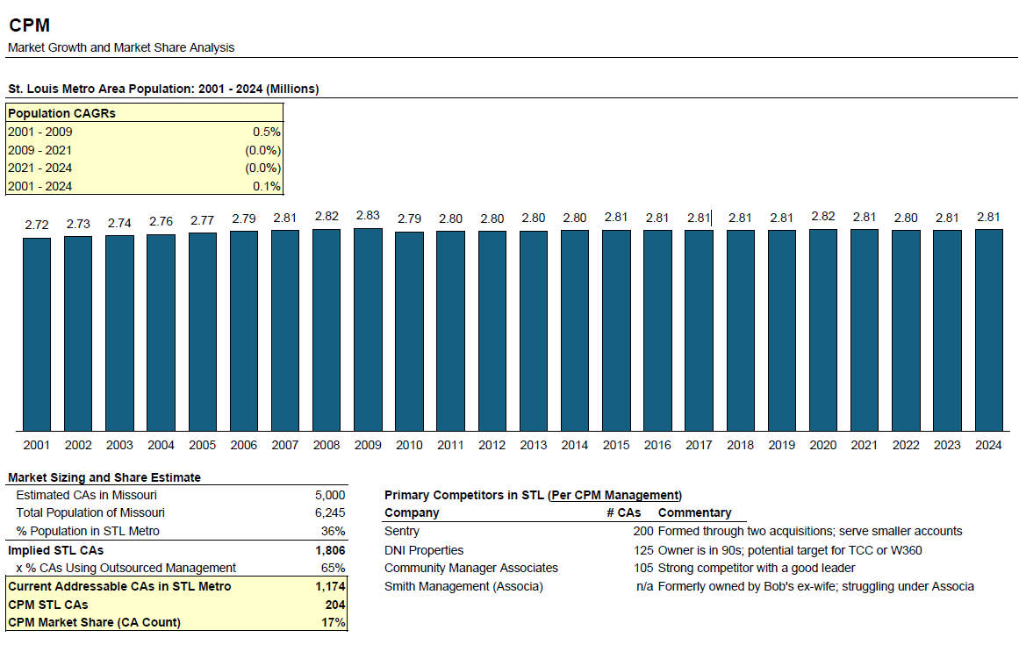

Commentary:
The St. Louis metro area has a large population but population growth has been flat over the last 20+ years. Over the past few decades, there has been a decline in manufacturing jobs, and some major employers either downsized or relocated, reducing the economic opportunities. The city itself has seen a declining population, but the suburbs are still seeing modest growth as families move out of the city for better school systems, lower taxes, and lower crime rates.

We estimate CPM’s market share to be 15-20% based on CA count. On a revenue basis it is probably higher given that they are focused on larger CAs (150+ units). CPM is likely the largest player in the St. Louis metro area with key competitors being Associa and Sentry.

Addendum Billing Opportunity
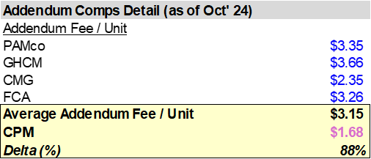
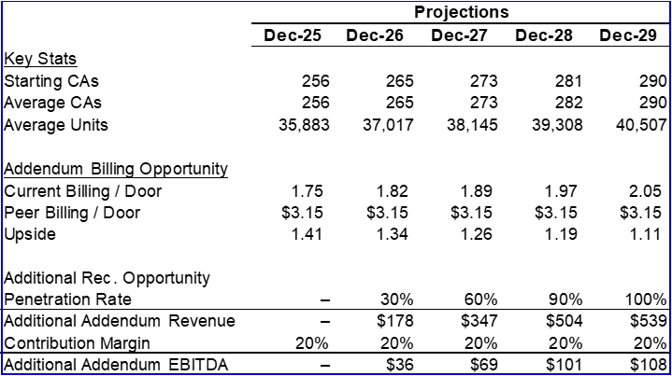

CPM currently has lower addendum billings per door than its closest peers within TCC when accounting for scale and mix of condos vs HOAs. CPM’s billing per door is approximately 55% of that benchmark.Key areas where CPM could increase billings include document handling (copy and mailing charges are ~50% of benchmark), portal access fees for association Vantaca access (for example, GHCM charges $65/license monthly), CTA processing (Cedar has charged $400 for related processing), and billable overtime charges (peers charging up to $25/hour more for the same employee levels).

Matching the benchmark for addendum billings poses a $500k+ annual revenue and $100k+ annual EBITDA opportunity using highly conservative contribution margin estimates.

Customer Concentration
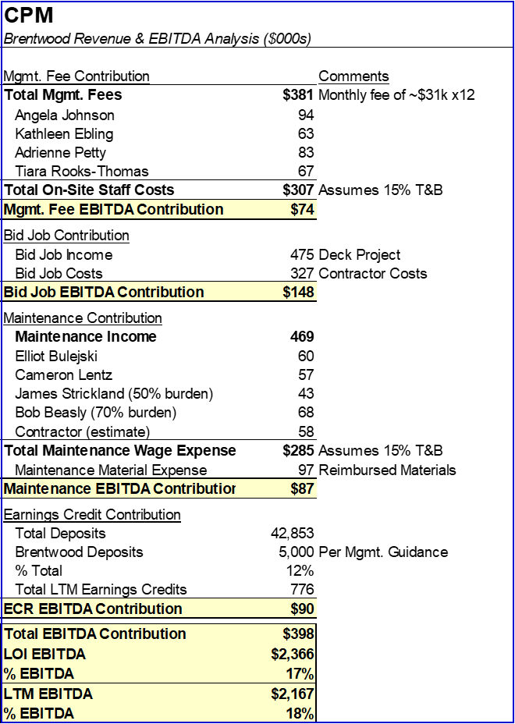

CPM’s largest customer is Brentwood Forest Condominiums, the largest condo complex in the state of Missouri. Brentwood has four dedicated onsite management personnel, three dedicated maintenance people, and is additionally in the midst of a significant capital improvement project being managed by CPM. Additionally, due to its size Brentwood averages ~$5M of deposits in bank accounts, which contributed meaningfully to earnings credit revenue. Given these diverse revenue streams, we estimate that Brentwood makes up 15-20% of overall earnings.

The customer relationship with Brentwood is strong, and Brentwood preemptively reached out to renew the contract and negotiations are ongoing. However, Brentwood is also going through a board election within the next month. Given these dynamics, we have agreed to sensitize the note in the event the new board board does not renew with CPM. The mechanism would reduce the note principal by 12x any decline in TTM EBITDA at note maturity, only if Brentwood is lost as a client.

